1ST Annual SCHODACK VALLEY SCARECROW CONTEST
& KIDS play Day in the Country

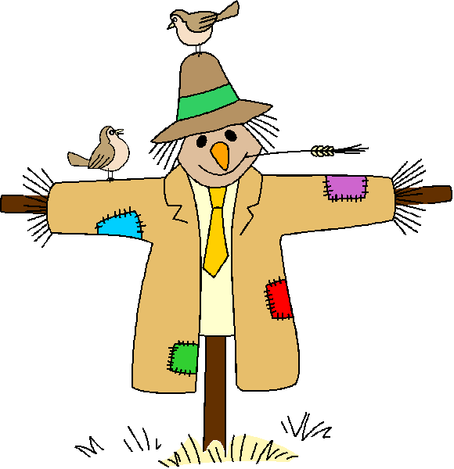
SATURDAY OCTOBER 22ND2005
Scarecrow Clinic at 12 Contest begins at 1 pm
Judging immediately following

Make Checks payable to: Goold Orchards
Return Entry Forms By Oct.19th to:
Goold Orchards
1297 Brookview Station Road
Castleton, NY 12033-3116
Entry Forms & Upcoming Event Information

Visit us on-line at
www.goold.com

Group or Family Name: _____________________

Street Address:___________________________ City_________________

State:_____ Zip Code:_________

How many in your Group________
Phone ___________Email______________

$5.00 per family entry Register by Wed. October 19th, 2005

Prizes for the scariest, silliest, traditional & most creative, Net Proceeds to

Benefit the Schodack- Castleton Library &
The Johnny Appleseed Book Fund.
Save the Date!!!!* Saturday October 29th
Dress up your bestest pet pal & Join us for
Halloween Pets on Parade!
We’ll Supply the Stake, Stuffing & Hay. You bring your best design & the clothes.
Scarecrow Clinic at Noon. Contest begins at 1pm. Judging at 3 pm.
We have a day full of activities planned.
So… Pack a picnic and Come spend a “Day In the Country”

